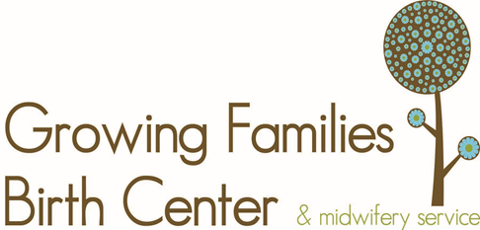
Warning Signs in Pregnancy

Call your midwife right away if you have any of these symptoms:
- Heavy bleeding
- Cramping
- Pelvic pain
- Fever of more than 100.4° F
- Unable to keep food or liquid down for 24 to 48 hours
- Spotting (light bleeding) that lasts more than one day

Signs of Preterm Labor

The symptoms listed below may signal the start of an early labor (preterm labor). If you notice any of these, first go to the bathroom and urinate, then drink several glasses of water and lie down on your left side and rest. If you still have these symptoms after an hour of rest, call your midwife:

- Contractions (not always painful) that come every 10 minutes or more often
- Cramping (like menstrual cramps) that’s either constant or on-and-off, and may come with diarrhea
- Low, dull backache that’s constant or that comes and goes
- Pressure in your pelvis, groin, or thighs (as if the baby is pressing down)
- Bleeding or spotting
- A change in vaginal discharge (a sudden increase in the amount of discharge, or discharge that is suddenly watery or full of mucus)
- A gush or a slow leak of fluid from your vagina
- A feeling that your uterus is “knotting up” or tightening, or that the baby is balling up inside
- A feeling that something just isn’t right

Call your midwife if you have any of these symptoms, they could signal pre-eclampsia or other problems:

- Constant or Severe Headaches
- Sudden swelling in your face or hands
- Pain in the upper right part of your abdomen
- Blurred vision or spots in front of your eyes
- Sudden weight gain (more than one pound in a day)
- Leaking or gushing of fluid from your vagina
- Decreased or no movement of your baby
- Any signs of preterm labor (see the list above)
- A feeling that something isn’t right

