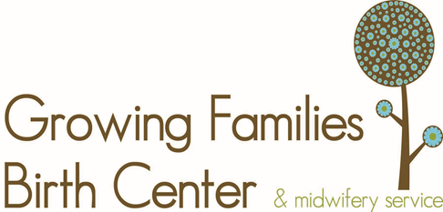
Herbs during Pregnancy

Herbs in pregnancy can be a great help when used properly, but when used improperly or using herbs that are not safe in pregnancy, they can be extremely dangerous. The following list of herbs will assist you in choosing herbs that are right for you. It is wise to ask your midwife about herbs before taking any. Many of the following herbs have not been evaluated by the FDA and must be used with knowledge and caution.

What’s Safe?

- Alfalfa- high in iron and vitamin k
- Black Haw- great for leg cramps and used in miscarriage
- Kelp
- Dandelion-Liver support and constipation
- Chamomile-Reduces constipation and aides in relaxation. (Avoid using in high doses)
- Cleavers-Diuretic used to reduce edema
- Cramp Bark-Helps prevent possible miscarriage as it calms the uterus
- Slippery Elm- Relieves constipation, nourishing
- Skull Cap- Headaches due to high blood pressure and aides in relaxation
- Squavine
- Rosehips
- Yellow Dock-low iron and constipation
- Peach Bark Leaves
- Red Raspberry Tea- Tones the uterus
- Milk Thistle
- Echinacea-for illness but must be taken in limited doses
- Nettle Leaf-High in iron
- Garlic-Used for infections
- Uva Ursi-Bladder infections (use under the care of your midwife)

What’s Not?

- Senna
- Goldenseal
- Dong quai
- Parsley
- Black cohosh
- Blue cohosh
- Barberry
- Bloodroot
- Buckthorn
- Cascara sagrada
- Cayenne
- Celandine
- Chapparal
- Cotton-Root Bark
- Ephedra
- Fennel
- Feverfew
- Flax seed
- Frankincense
- Juniper
- Lady’s Mantle
- Lavender in High Doses
- Licorice
- Shepherd’s Purse
- Mugwort
- Pennyroyal
- False unicorn-Use under care of midwife only

