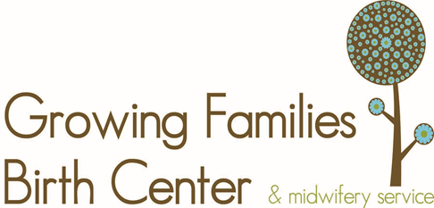

Tobacco Use and Pregnancy

Effects on the unborn and newborn baby:
- Smoking robs baby of nutrients
- Smoking damages the growing baby’s brain through lack of oxygen and chemicals
- Low birth weight babies are common for smoking mothers
- Increased risk of SIDS
- Nicotine narrows uterine blood vessels thus reducing the blood flow to baby
- Children whose mother’s smoke can have mental and behavioral problems throughout childhood and adolescence

Second hand smoke does a lot of harm to the mother and baby also
- Increased risk of SIDS
- Smoking damages the growing baby’s brain through lack of oxygen and chemicals

Advantages of Quitting
- Less wrinkles, acne and blackheads (Healthier Skin)
- More vitality as breathing is easier and more effective
- Sense of taste is increased and food tastes better
- Now is a good time to gain a few pounds from quitting; after all you’re pregnant and will gain weight anyway
- An easier labor
- Easier to exercise and get the great health benefits of exercising
- Longer healthier life to enjoy with your new baby as they grow

Tips on Quitting
- Tobacco Free Florida Support Line (877) 777-6534 (Let them know you are pregnant)
- Attempt quitting cold turkey
- Avoid smoking a whole cigarette down to the end, only smoke it half way (the end has more toxins)
- Switch to a less toxic brand like American Spirit or Native
- Ask for support, encourage other smokers not to smoke around you
- Don’t go to places or do things where you smoke
- Hypnosis and/or acupuncture
- Chew gum
- 100% Pure Black Pepper Essential Oil (Reduces symptoms of withdrawal)

